Michelle Wright
BA Fine Art (Hons)
Fine Art in Context 2 (ARF 501)
Select one of the lecture topics from Semester One from which to explore and analyse the work of a single artist.
You should restrict your analysis of their work to a key period and consider how it could be analysed and discussed from different perspectives.

Modern Trends: Social Media and the Activist Artist
29th March 2017
Since the introduction of Social Media into the modern world, the Activist Artist has been able to promote social, political, economic or environmental reform to a global audience.
This Essay explores the use of Social Media by Ai Wei Wei to support his activism and his artwork. (full synopsis continued overleaf)

Assignment 1
Select one of the lecture topics from Semester One from which to explore and analyse the work of a single artist. You should restrict your analysis of their work to a key period and consider how it could be analysed and discussed from different perspectives.

Modern Trends: Social Media and the Activist Artist

Synopsis
Since the introduction of Social Media into the modern world, the Activist Artist has been able to promote social, political, economic or environmental reform to a global audience. This Essay explores the use of Social Media by Ai Wei Wei to support his activism and his artwork.

Ai Wei Wei
Since 2005 Ai Wei Wei, in particular has used Social Media platforms to communicate his political and social messages to a global community with the intention of bringing about social change. However, this global attention to his work has placed him personally at great risk and brought about a difficult relationship with the Chinese Authorities, who censor the availability of Social Media within their geographical borders.
Ai Wei Wei uses his popularity on social media to bring the world’s attention to ongoing refugee crises and uses somewhat shocking imagery to evoke a psychological response from his audience, the concept of which has been considered by artists for some time, but is even more prevalent today’s world with the continued use of Social Media and the Internet to campaign for political or social change.
This essay discusses the event of the Sichuan Earthquake and the period following from 2008 to 2012 and the use of social media platforms and contemporary art form by Ai Wei Wei to bring awareness to the students who were not named by the Chinese Authorities when they released the official student death toll and the scandal surrounding the structure of the school buildings that collapsed.

Modern Trends: Social Media and the Activist Artist

Essay Response
The Activist Artist Ai Wei Wei has long been renowned for his extensive use of social media to campaign for social or political change. Having had little to no exposure to the internet prior to 2005, he quickly developed the ability to use his blog and social media accounts, particularly Twitter and Instagram as a platform to air his dissident views. Taking advantage of the international forums on the internet and managing to technologically step outside the boundaries of the Internet Censorship of the Chines Authorities he has become known world-wide as China’s most controversial artist.
Since 2005, Ai Weiwei has engaged a range of digital media platforms as the principal means to communicate and maintain a relationship with his followers, both within China and the world at large. Mostly, from his broad blogging activities to his creative use of Instagram and Twitter, as well as his establishment of ironic memes and online videos, photos and audio recordings, Ai has thoroughly harnessed the strength of the Internet as a resourceful tool for public expression and conversation.¹
In May 2008 a catastrophic earthquake occurred in the Sichaun province of China, considered to be the 21st deadliest earthquake of all time. It is suggested that 69,000 people lost their lives, and over 18,000 people were reported missing. Many buildings collapsed or were damaged, however perhaps the most shocking statistic is that at least 7000 school buildings collapsed resulting in the deaths of many thousands of school children.
The Chinese Authorities responded quickly with an impressive relief effort, investing millions of pounds in the re-building of the infrastructure and the buildings in the Sichuan area, however they were also criticised for mistakes made prior to the Sichuan earthquake, in particular the “shoddy” workmanship and construction of the school buildings where many students had died.
By coincidence, and although considered politically sensitive, an official number of student deaths (5,335) was released by the Chinese Authorities in May 2009 seeming a response to Ai Wei Wei and other Chinese Activist to release the names and number of student deaths. There were no names released with the official number of student deaths. It is widely believed that the actual total to be more than twice the official figure provided.
BEIJING — A year after the massive Sichuan earthquake levelled hundreds of schools, sparking allegations of corruption and shoddy construction, China finally gave Thursday its first official tally of the numbers of students dead or missing: 5,335.²

It appears that the majority of these deaths occurred in only 18 schools (approximately 3500) out of the 14,000 that had been damaged. In his blog, Ai Wei Wei questioned the validity of the number released by the Chinese Authorities suggesting that the discrepancy between his own findings and the official figure is the reason that the Authorities were reluctant to release any of the names of the deceased students.
While no specific event was held on May 12, as of May 23, the project has recorded the names of 5,190 students. Ai notes that the majority of those deaths—around 3,500—occurred in just 18 of the 14,000 damaged schools. He is quick to point out the discrepancy between his figure and the Authorities’, and he openly questions the veracity of the Authorities’ numbers in light of their reluctance to release a list of names. A May 23 entry on Ai’s blog, which details the project’s methodology and findings to date, was meant to contrast with the Authorities’ silence about its methodology. The artist believes his current figure represents 80 percent of those killed.³
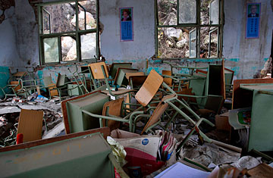
The poor construction of the school buildings that had collapsed provoking media attention and a wider discussion about the quality of buildings which were considered to have been of sub-standard construction began.
1. A classroom of Beichuan New Middle School in Sichuan province. Most of the school was destroyed by the May 2008 earthquake
This then led to allegations of corruption against Chinese Authorities Officials who had been instrumental in the construction of these schools.
Parents say the schools crumbled so easily because corruption and mismanagement led to slipshod construction and weak buildings that were not up to code. Some say materials meant for school construction projects were sold on the side by contractors for personal gain.⁴
These investigations were later suppressed by the Chinese Authorities which attracted Ai Wei Wei’s attention. Ai Wei Wei wanted the Chinese Authorities to be held accountable and to take responsibility for the deaths that potentially could have been avoided had it not been for their negligence when the school buildings were constructed.
The earthquake demolished over 7,000 classrooms, and killed thousands of students. The large death toll led to wide discussion about the quality of the school buildings. This, in turn, led to allegations of corruption against Authorities officials and construction contractors, who were complicit in constructing sub-standard school buildings while pocketing the remaining surplus. The scandal soon became a focal point of reporting. Despite initial openness to media’s crisis reporting, the Chinese Authorities issued notice to media outlets ordering them to downplay the issue, and forced China’s most famous liberal press, Southern Metropolis Daily and foreign media to withdraw from the earthquake zone in case they further investigated the scandal² (Weaver 2008). When media’s investigative reporting of the scandal was suppressed, some social activists, public intellectuals, and activist bloggers initiated independent investigation projects to further look into the issue. Amongst them, Ai Weiwei’s citizen investigation project was one of the most well-known and influential projects.⁵
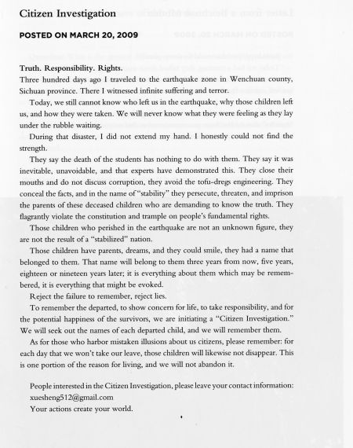
In December 2008, dissatisfied with the position that the Chinese Authorities had taken regarding the release of the student death toll and the lack of accountability in the Chinese Authorities, for the poor construction of the affected schools, Ai Wei Wei established the Citizen Investigation Group who began the process of collecting information on the student casualties.
2. Citizens Investigation Posted on March 20, 2009
Citizens' Investigation marks a turning point in Ai's life, work, and missionAi's work. He has used the outcome of the project for highly visible public artworks, to begin with So Sorry, his solo exhibition in the Haus der Kunst (Munich, 2009).⁶
They found as much information online as they possibly could before sending researchers to the affected villages to directly collect as much information from the remaining relatives of the deceased students, compiling lists of student victims for each school affected. Reinforcement Bars were also salvaged from the collapsed buildings by volunteers over a period of two years which were taken to Ai Wei Wei’s studio and later straightened by a team of labourers.
In March 2009 Ai Wei Wei then began posting information collected by the Citizen Investigation Group which brought about an extensive online discussion about this investigation.
In a blog post titled "Citizen Investigation" on March 20th, 2009, he wrote: "To remember the departed, to show concern for life, to take responsibility, and for the potential happiness of the survivors, we are initiating a citizen investigation." Issuing an open call for citizen participation, Ai succeeded in recruiting around 100 volunteers on-line for the investigation.⁷
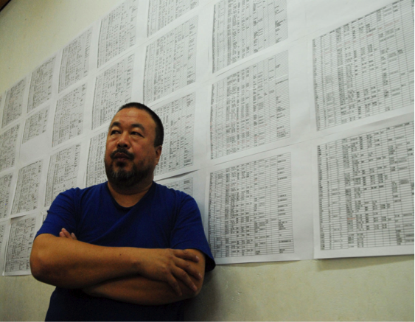
The scandal surrounding the construction of the school buildings re-emerged and Ai Wei Wei’s blog was then considered to be a reliable source for the truth surrounding this scandal.
3. Ai Weiwei with his list of names of schoolchildren who died in the 2008 Sichuan earthquake, posted on the wall in his studio in Beijing.
The page view of Ai Wei Wei’s blog reached over 10 million views and his blog entries were widely reposted by other internet sites and Ai Wei Wei took advantage of international sites to publicise this topic which had been censored by the Chinese Authorities and banned as politically sensitive topic.
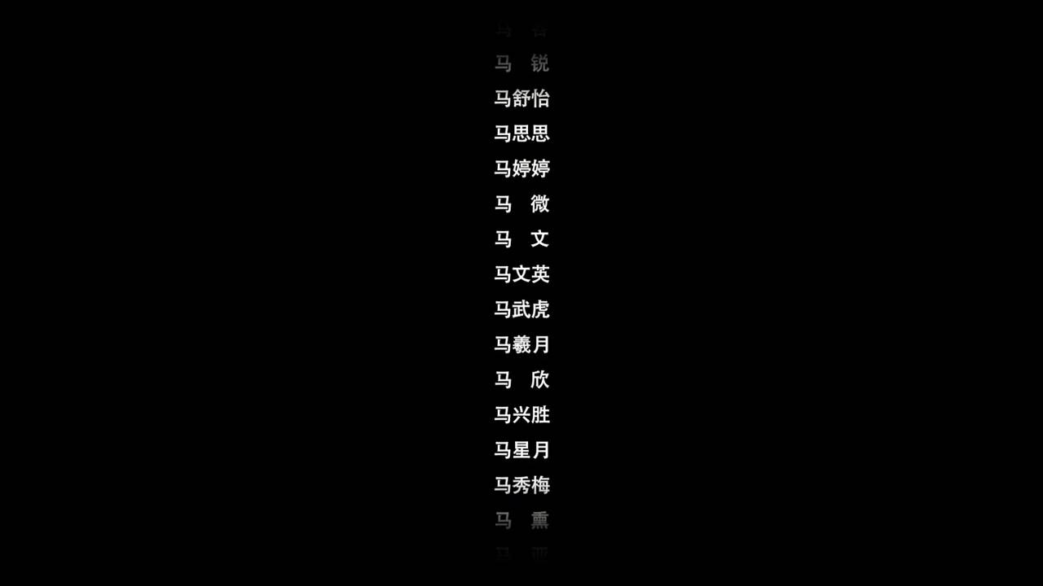
Ai Wei Wei then used his blog to encourage volunteers to participate in the project and recruited volunteers to continue his investigation on the ground in the Sichuan area.
4. Still from the video 4851
In May 2009 the Chinese Authorities shut down the blogs created by Ai Wei Wei. He was able to continue blogging, however by reposting his blog entries on Bullogger.com, and although this website was also blocked in China, people with the right technological knowledge were able to access the site and repost the entries on the Chinese internet.
Recently, however, the blog entries have been translated and compiled into the book Ai Weiwei’s Blog: Writings, Interviews, and Digital Rants 2006-2009.
In Late 2009 Ai Wei Wei released the 87-minute documentary video 4851 which presents a simple rolling list of all the names found by the Citizens Investigation Group displayed against a black background, that serves as a poignant artistic memorial to the students who had lost their lives in this tragedy.
This 87 minutes long video was dedicated by Ai weiwei and myriad volunteers as a memory of those innocent departed lives. The black background with violin and stringed music which penetrates throughout the entire video delivers endless grief. The 4,851 names are shocking by sight like 4,851 funerals and can even bring out some tears.⁸
The piece Hua Lian Ba Er, translated as Dirty Faces was released at the same time, is a documentary that discusses the investigation of the scandal surrounding the construction of the school buildings that collapsed in the Sichuan Earthquake. It is suggested that this work contributed the most to his mis-treatment at the hands of the Chinese Authorities and this work is certainly at the crux of the pivotal period between 2008 and 2009 where his association with the Chinese Authorities changed radically.
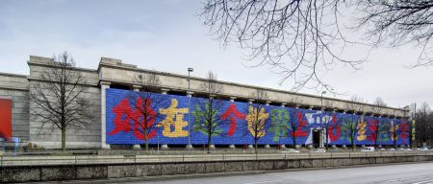
5. "Remembering" (2009) is Ai Weiwei's 1,000 square meter long installation made out of school bags
The piece Remembering (2009) comprised of 9000 children’s backpacks spells out “She lived happily in this world for seven years”, a quote from a parent, became the centrepiece of the solo exhibition, So Sorry in Munich, Germany where the inference in the title is the apologies that are made by large organisations, corporations and governments when tragedy happens as a result of their negligence.
The idea to use backpacks came from my visit to Sichuan after the earthquake in May 2008. During the earthquake many schools collapsed. Thousands of young students lost their lives, and you could see bags and study material everywhere. Then you realize individual life, media, and the lives of the students are serving very different purposes. The lives of the students disappeared within the state propaganda, and very soon everybody will forget everything.⁹
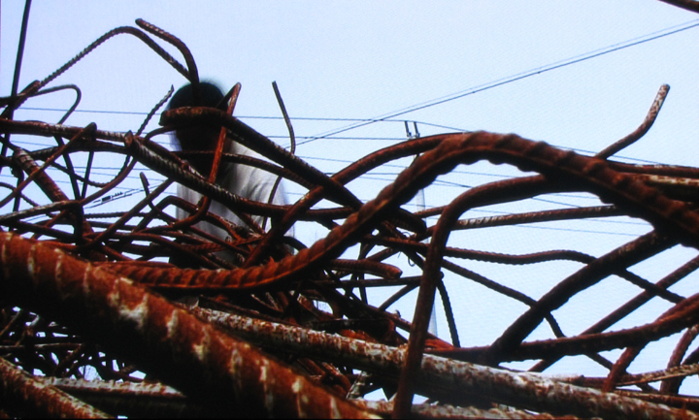
In the five years that followed the Sichuan earthquake the volunteers of the Citizens Investigations Group recovered 150 tonnes of steel rebar from the collapsed schools in the Sichuan area. Each piece of Reinforced Bar painstakingly straightened and then presented as the piece Straight in 2013 at the Venice Biennale.
6. “This gesture is charged with symbolic value, showing us the artist’s ability to create a profound connection with the social and economic [and political] issues of contemporary China,” says curator Maurizio Bortolotti.
The works were displayed in the Sant’Antonin Church and in the process of straightening each rebar, Ai Wei Wei metaphorically attempts to make things right.
The work is composed of 150 tons of steel rebar which the artist recovered from the sites of the collapsed schools in sichuan following the quake. varying in diameter, ai weiwei has had all of the retrieved metal parts straightened as if new, and has arranged them in stacks, creating an eery landscape which immediately brings forth a feeling of somberness in memory of those whose lives were lost; the action of adjusting the pieces in a way metaphorically speaking of the artist trying to make things right.¹⁰
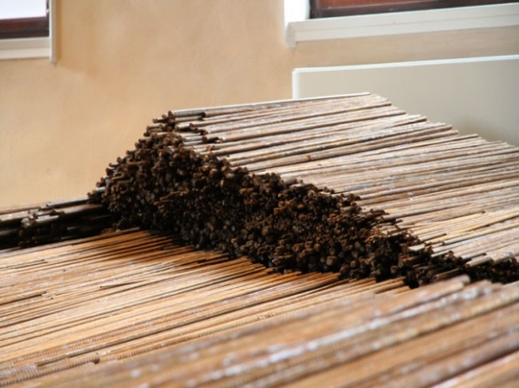
The final installation of straight presents a landscape that evokes a sense of peace and calm with a sombre emotion that comes from knowing the source of the reinforced bars and the historical event that they became part of, you cannot help but think about the victims when you look at this piece. Looking at the installation from different viewpoints allows you to perceive cracks in the structure that mimic faults in the landscape or tectonic plates where there would be potential for an earthquake to occur.
7. 150 tons of steel rebar recovered from the schools which collapsed in sichuan china were straightened
When the earthquake struck many people volunteered to help in the relief effort in an attempt to give something back to the Chinese Authorities for benefit received in other ways. The Chinese Authorities have worked hard to unify the Chinese population as a whole, and although the censorship is difficult from a western perspective, this censorship serves to bring about this unity in the population.
The relief effort, recovery and reconstruction became the focus for the reporting of the earthquake, taking the attention away from the loss of life and poor construction of schools.
One of the most astonishing aspects is the speed and efficiency with which the Chinese Authorities was able to mobilize Authorities agencies, the private sector and the population at large.
Soon after the disaster, the planning process for recovery and reconstruction efforts took off, including the optimization of the urban layout during reconstruction, the restoration and reconstruction of rural production and living facilities, the provision of health services; the creation of cultural, sporting and other public service facilities; the strengthening of disaster prevention and relief systems; the restoration of the ecological landscape; and the provision of psychological support of the affected population
Some RMB108 billion (US$ 16.6 billion) were spent in these facilities, including investments in medical and sanitation facilities and social management. Schools and hospitals are now fully restored and reconstructed, in addition to social welfare houses, elderly homes, community service centers, village activity centers, etc..¹¹
The propaganda released by the Chinese Authorities officials in the aftermath of the earthquake served to protect this unification by instructing Chinese Journalists to only present positive images of the relief effort through their media outlets, television, newspapers and censored internet activity.
Then Li Changchun, the party leader in charge of publicity, told reporters to present positive images of the relief effort. From that point on, China's television screens and newspapers have been filled with endless shots of soldiers parachuting from aircraft and grateful children holding up signs extolling the People's Liberation Army.¹²
Indeed, those that sought to bring the issues surrounding the school building scandal and the publication of student deaths and their names into the public arena were portrayed as the disruptive minority and targeted by the Chinese Authorities. Ai Wei Wei, in particular has put his life and that of his family at risk in pursuit of his mission to raise the public awareness of these issues.
It seems that the period between 2008 and 2009 was a particularly pivotal moment in Ai Wei Wei’s life. In 2008 he was the artistic consultant for the Beijing Olympic Stadium along with Swiss architects Herzog & de Meuron. He later refused to attend the opening ceremony because of the one-party state and the disgusting political conditions.
All the shitty directors in the world are involved. It's disgusting," said Ai. "I don't like anyone who shamelessly abuses their profession, who makes no moral judgment. It is mindless.¹³
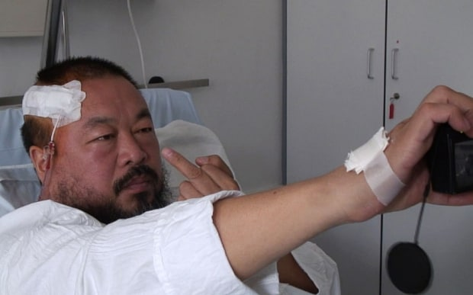
In the following year, 2009, his blog was taken offline by the Chinese Authorities, the police threatened him at his home and a few short months later, just two months before the opening of the So Sorry Exhibition in Munich, he required emergency brain surgery after being beaten in a hotel room by police.
8. Ai Weiwei taking a selfie in hospital after being beaten by police in 2009
He was later arrested in 2011 at Beijing Airport and placed under house arrest over an extended period (some four years) for his outspoken criticism of the Chinese Authorities. They even went to the extent of demolishing his studio that they had invited him to build.
Having received this travel ban after this arrest, he was prevented by the Chinese Authorities from leaving his native country, China, it took some four years for him to have his passport returned to him.
But the arrest of Ai and the others appeared to mark what human rights groups and others called a new and more sinister phase in China’s ongoing, and typically cyclical, repression of dissidents. In the past, such sweeps of activists have preceded major events on the calendar — the 2008 Olympics, major Communist Party meetings or the Nobel Prize ceremony in Oslo last December — and have receded once the event ended.
The arrests of bloggers and writers, in particular, on subversion charges suggests a rollback of the limited open space recently allowed for free opinion on the Internet and particularly on popular Twitter-like microblogging sites. ¹⁴
It is worth also considering that it is not just his outspoken views and his blogging activities and that it may also be his hard hitting, socio-political documentary based filming activities that openly defy the Chinese Authorities and their desire for the unification of the Chinese population and the Rule utilitarianism that seems to exist in China. In my opinion, these films most definitely contribute to his agitation of the Chinese Authorities and the fact that he is targeted on a personal level. It does seem ironic that someone who is so passionate about the freedom of speech, human rights and standing up to those who suffer at the hands of large corporations or Authorities experiences so much censorship of his own activities, including his imprisonment and curtailment of his ability to travel freely at the hands of the Chinese Authorities.
It is clear that Ai’s outspoken internet postings and his activism contributed to his detention, but another related cause that has been less explored in overseas discussions is his role as a documentary filmmaker. Working with a production team organized through his Beijing studio—his residence and his main headquarters located in the northwest corner of the capital—Ai has released eight guerrilla-style documentaries and many short online videos that, in their rough style and critical approach, seek to initiate a space of open inquiry and free speech around social issues in China.¹⁵
To conclude, this is definitely a period in history where differing points of view are apparent. At a time when the world is becoming technologically advanced, China still seeks to unify its population through censorship. However, this disruptive minority still manages to get their viewpoint into the international public arena for debate and to raise awareness.
Described as the most dangerous artist in the world, his work continues to split opinion. He continues to make artwork that raises awareness of social or political issues, including work that addresses human rights and the freedom of expression.
His work is dedicated and prolific and for that alone, he should be commended, however his strength of character and his ability to stand against the powers that be and say “this is not right” and to speak up for those who have no voice, irrespective of the personal consequences of these actions only deserves the greatest of respect.

References: Quotes
- Coshamie. (2017). Ai Weiwei And The Power Of Social Media. [online] Available at: http://coshamie.com/ai-weiwei-and-the-power-of-social-media/ [Accessed 9 Mar. 2017].
- Wire-Datastream, &. (2017). China — 5,335 students dead, missing in 2008 quake. [online] PostBulletin.com. Available at: http://www.postbulletin.com/china-students-dead-missing-in-quake/article_128d67c3-9b06-5b7f-a7f5-8ecd83dd42fc.html [Accessed 9 Mar. 2017].
- Artasiapacific.com. (2017). ArtAsiaPacific: Ai Weiwei Challenges Chinas Authorities Over Earthquake. [online] Available at: http://artasiapacific.com/Magazine/64/AiWeiweiChallengesChinasAuthoritiesOverEarthquake [Accessed 10 Mar. 2017].
- Wire-Datastream, &. (2017). China — 5,335 students dead, missing in 2008 quake. [online] PostBulletin.com. Available at: http://www.postbulletin.com/china-students-dead-missing-in-quake/article_128d67c3-9b06-5b7f-a7f5-8ecd83dd42fc.html [Accessed 9 Mar. 2017].
- Civic Media Project. (2017). Civic Media Project: Blogging for Truth: Ai Weiwei’s Citizen Investigation Project on China’s 2008 Sichuan Earthquake. [online] Available at: http://civicmediaproject.org/works/civic-media-project/bloggingfortruthaiweiweiscitizeninvestigation [Accessed 9 Mar. 2017].
- Multiple Journalism. (2017). Citizens' Investigation | Multiple Journalism. [online] Available at: http://multiplejournalism.org/case/citizens-investigation [Accessed 9 Mar. 2017].
- Multiple Journalism. (2017). Citizens' Investigation | Multiple Journalism. [online] Available at: http://multiplejournalism.org/case/citizens-investigation [Accessed 9 Mar. 2017].
- Muse.union.edu. (2017). 4851 Documentary Video By Ai Weiwei | AAH 194 Visual Culture in Communist China. [online] Available at: https://muse.union.edu/aah194/2014/09/29/4851-documentary-video-by-ai-weiwei/ [Accessed 9 Mar. 2017].
- Khan Academy. (2017). Khan Academy. [online] Available at: https://www.khanacademy.org/humanities/global-culture/global-art-architecture/a/ai-weiwei-remembering-and-the-politics-of-dissent [Accessed 9 Mar. 2017].
- designboom | architecture & design magazine. (2017). ai weiwei straightens 150 tons of steel from sichuan quake. [online] Available at: http://www.designboom.com/art/ai-weiwei-straightens-150-tons-of-steel-rebar-from-sichuan-quake/ [Accessed 9 Mar. 2017].
- East Asia & Pacific on the rise. (2017). Four years on: What China got right when rebuilding after the Sichuan earthquake. [online] Available at: http://blogs.worldbank.org/eastasiapacific/four-years-on-what-china-got-right-when-rebuilding-after-the-sichuan-earthquake [Accessed 9 Mar. 2017].
- Telegraph.co.uk. (2017). China earthquake: Beijing seizes on rescue for Olympic propaganda. [online] Available at: http://www.telegraph.co.uk/news/worldnews/asia/china/2016887/China-earthquake-Beijing-seizes-on-rescue-for-Olympic-propaganda.html [Accessed 9 Mar. 2017].
- Watts, J. (2017). Olympic artist attacks China's pomp and propaganda. [online] the Guardian. Available at: https://www.theguardian.com/world/2007/aug/09/china.artnews [Accessed 9 Mar. 2017].
- Richburg, K. and Richburg, K. (2017). Chinese artist Ai Weiwei arrested in ongoing Authorities crackdown. [online] Washington Post. Available at: https://www.washingtonpost.com/world/chinese-artist-ai-wei-wei-arrested-in-latest-Authorities-crackdown/2011/04/03/AFHB5PVC_story.html?utm_term=.f6309afce222 [Accessed 9 Mar. 2017].
- Sniadecki, J. (2017). Documentary Is Just One of My Tools: The Digital Film Activism of Ai Weiwei - Cinema Scope. [online] Cinema Scope. Available at: http://cinema-scope.com/cinema-scope-magazine/interviews-documentary-is-just-one-of-my-tools-the-cinematic-activism-of-ai-weiwei-by-j-p-sniadecki/ [Accessed 9 Mar. 2017].

References: Images
- TIME.com. (2017). Breaking News, Analysis, Politics, Blogs, News Photos, Video, Tech Reviews - TIME.com. [online] Available at: http://content.time.com/time/world/article/0,8599,1897567,00.html [Accessed 9 Mar. 2017].
- Multiple Journalism. (2017). Citizens' Investigation | Multiple Journalism. [online] Available at: http://multiplejournalism.org/case/citizens-investigation [Accessed 9 Mar. 2017].
- Civic Media Project. (2017). Civic Media Project: Blogging for Truth: Ai Weiwei’s Citizen Investigation Project on China’s 2008 Sichuan Earthquake. [online] Available at: http://civicmediaproject.org/works/civic-media-project/bloggingfortruthaiweiweiscitizeninvestigation [Accessed 9 Mar. 2017].
- YouTube. (2017). 4851. [online] Available at: https://www.youtube.com/watch?v=qssniSdhQO8 [Accessed 9 Mar. 2017].
- Multiple Journalism. (2017). Citizens' Investigation | Multiple Journalism. [online] Available at: http://multiplejournalism.org/case/citizens-investigation [Accessed 9 Mar. 2017].
- Art in The heArt of Summer. (2017). Disposition: Straight. Ai Weiwei at the 55th Venice Biennale.. [online] Available at: https://artintheheartofsummer.wordpress.com/2013/09/05/disposition-straight-ai-weiwei-at-the-55th-venice-biennale/ [Accessed 10 Mar. 2017].
- designboom | architecture & design magazine. (2017). ai weiwei straightens 150 tons of steel from sichuan quake. [online] Available at: http://www.designboom.com/art/ai-weiwei-straightens-150-tons-of-steel-rebar-from-sichuan-quake/ [Accessed 9 Mar. 2017].

